Using the DBGI Project Registration Portal
Step-by-step scenarios for company users and DBGI administrators
DBGI Project Registration Portal | User guide | 2026-10-26
How to use this guide: every scenario follows one real registration, DBGI-000012, from the day it was submitted to the day its price was approved. The screenshots come from the portal's test environment, using a demo company called DEMO ONLY - Sample Partner. Your screens will show your own company and data.
The example deal: Pasig City Schools Division Office needs 20 monochrome laser printers (model M1820W, list price PHP 10,000 each). Canon is offering PHP 9,300, so the dealer asks DBGI for PHP 9,000.

1. Before you start

Two kinds of users
Role | Who they are | What they do in the portal
Company user | Staff of a partner dealer | Register deals, answer DBGI's questions, check decisions, approved prices, and rankings.
DBGI administrator | DBGI staff | Review registrations, decide matches and prices, maintain End-users, products, and other master data.

Signing in and finding your way
- Sign in with the username and password DBGI gave you.
- The top menu has Rankings, Notifications, Help, and Log out. Administrators also see Administration.
- The Registrations page lists your registrations. Click a reference such as DBGI-000012 to open one.
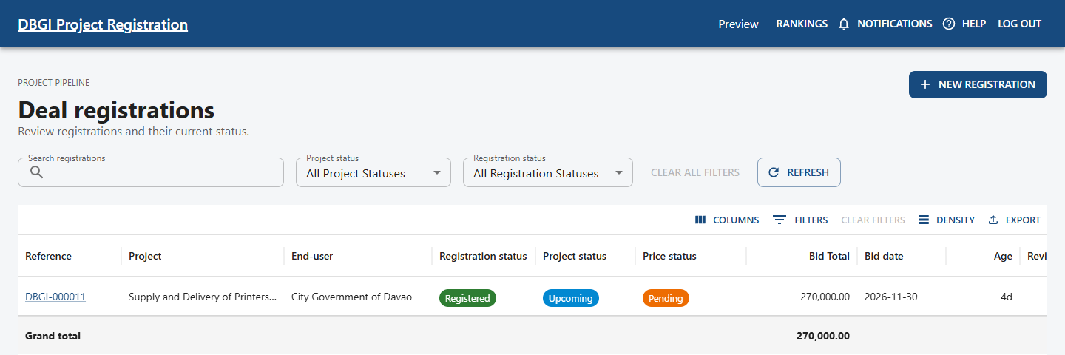
Figure 1. The Registrations page, with NEW REGISTRATION at the top right.

Reading the three status badges
Every registration shows three badges at the top. They answer different questions, so read them separately.
Badge | Question it answers | Possible values
Registration status | Has DBGI accepted the deal? | Submitted, Under review, Changes requested, Resubmitted, Registered, Review required after edit, Rejected
Project status | Is the procurement itself going ahead? | Not linked, Upcoming, Active, Won, Lost, Cancelled, On hold
Pricing status | Has DBGI decided the price? | Pending, Changes requested, Partially approved, Approved, Rejected, Expired
A deal can be Registered while its pricing is still Pending. Hover over any badge in the portal to see what it means.

2. Submit a new registration
Who: Company user
Before you start: the buyer's name, the project title, bid and delivery dates, at least one competitor offer, the product and quantity you need, the price you want to request, and a description of your evidence.

Step 1: who and what
- On the Registrations page, select NEW REGISTRATION.
- In End-user, type part of the buyer's name and pick the match. A green line confirms the address and that DBGI verified it.
- If the buyer is not listed, select ADD MISSING END-USER. DBGI verifies new End-users later.
- Enter the project title, bid date, and delivery date.
- Check the contact details. They are filled in from your profile.
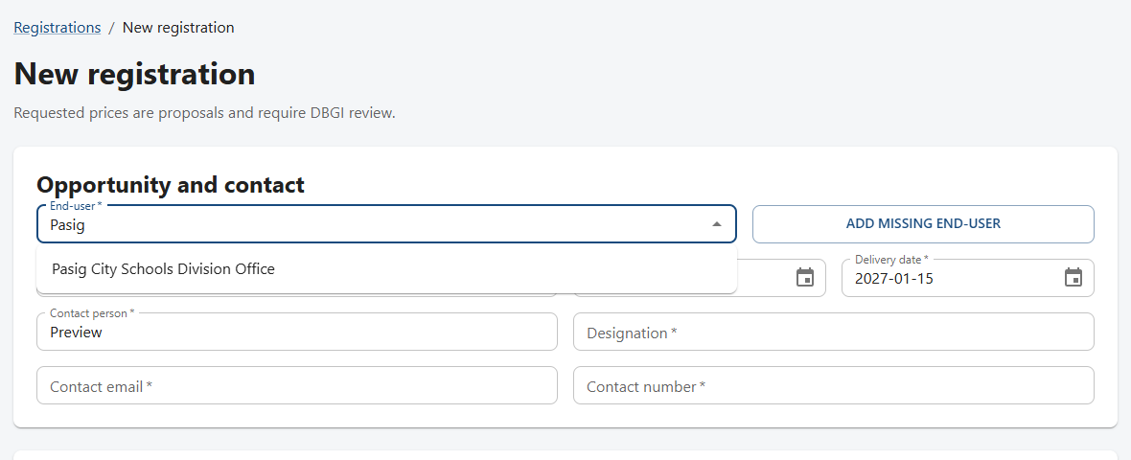
Figure 2. Searching for the End-user.
Register each real opportunity once. To fix something later, edit the existing registration. Do not create a second one.

Step 2: competitor and products
- Under Competitor items, select ADD COMPETITOR. Pick or type the brand and model, enter their bid price, and add a remark. Only your company and DBGI can see this.
- Under Requested products, select ADD PRODUCT. Choose the catalog product, then enter quantity, the unit price you are requesting, and your justification.
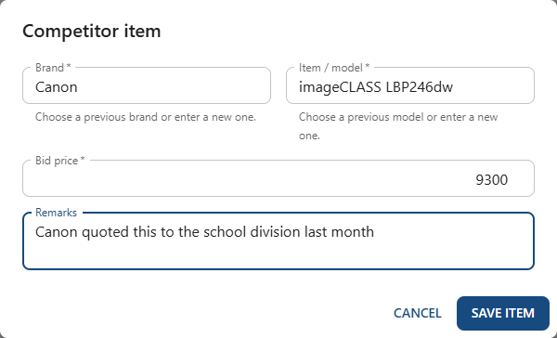
Figure 3. Adding a competitor offer.
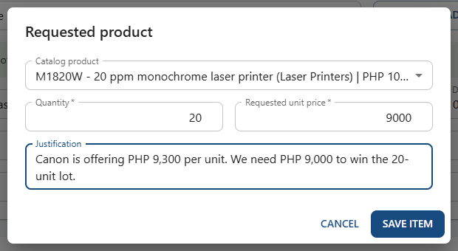
Figure 4. Adding a requested product.

Step 3: evidence and submit
- In Evidence description, explain how you learned about the deal. Include dates and reference numbers if you have them.
- Add files if available. Never upload another company's pricing, personal IDs, or signatures.
- Tick I confirm that I am authorized to share this evidence with DBGI for review.
- Select CREATE REGISTRATION.
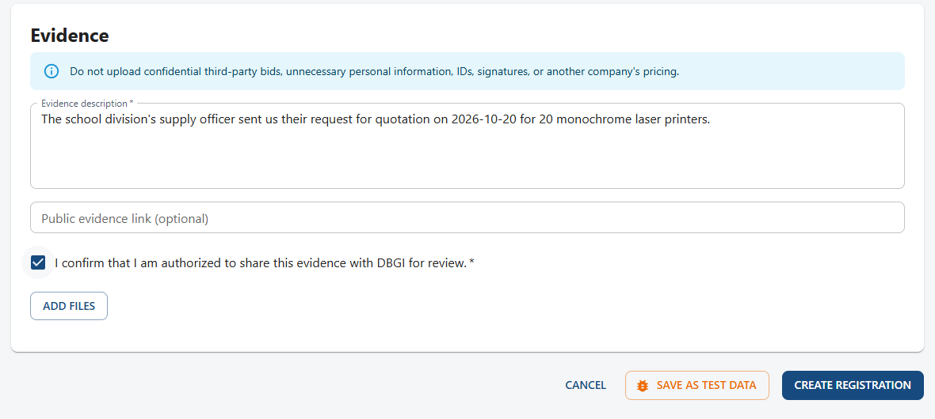
Figure 5. The Evidence section and the CREATE REGISTRATION button.

Expected result
The registration gets a DBGI reference (here DBGI-000012) and shows Submitted, Project: Not linked, and Pricing: Pending. A Submission confirmed notification appears, and the Activity list records the submission.
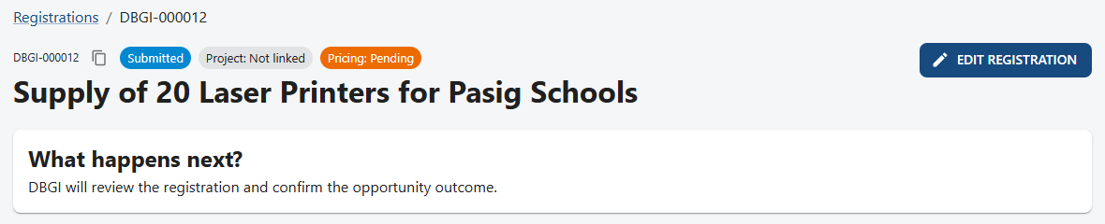
Figure 6. The new registration with its reference and badges.
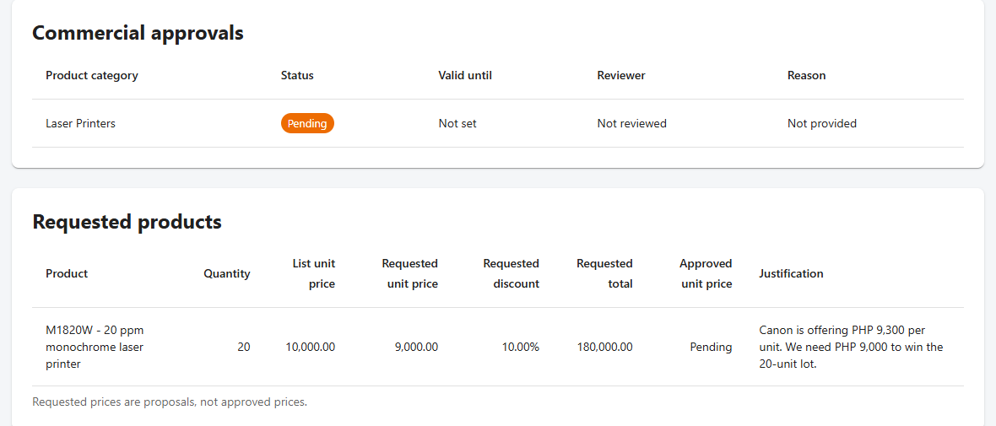
Figure 7. The portal works out the requested discount and total. The approved price stays Pending.
A requested price is only a proposal. Do not promise it to the buyer until DBGI approves it.

3. Follow your registration through Notifications
Who: Company user
Before you start: a submitted registration.
- Select NOTIFICATIONS in the top menu.
- Unread notifications are marked. Select VIEW REGISTRATION to open the deal.
- Email may send you a copy, but the portal notification is the official record.
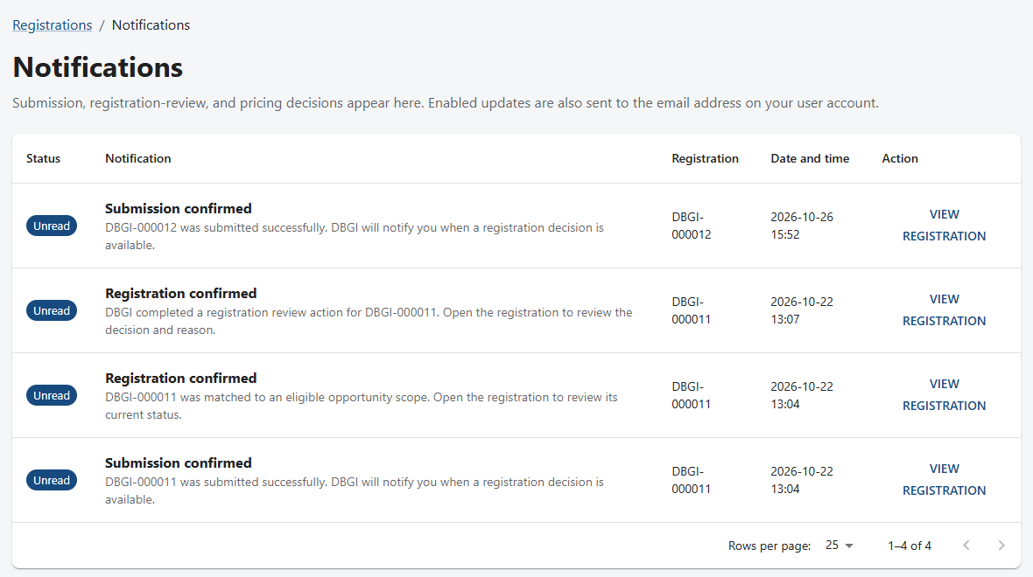
Figure 8. The Notifications page.

4. Review a registration and request changes
Who: DBGI administrator
Before you start: a registration with status Submitted. In the example, the evidence did not say which procurement it belonged to, so DBGI asked for the RFQ reference.

Step 1: find the work
- Sign in. Administrators land on the Operations dashboard.
- The cards count what is waiting: registration reviews, pricing decisions, End-users to verify, failed emails, and approvals expiring within 30 days.
- Open the registration from the Registration review queue, or open it from the Registrations page.
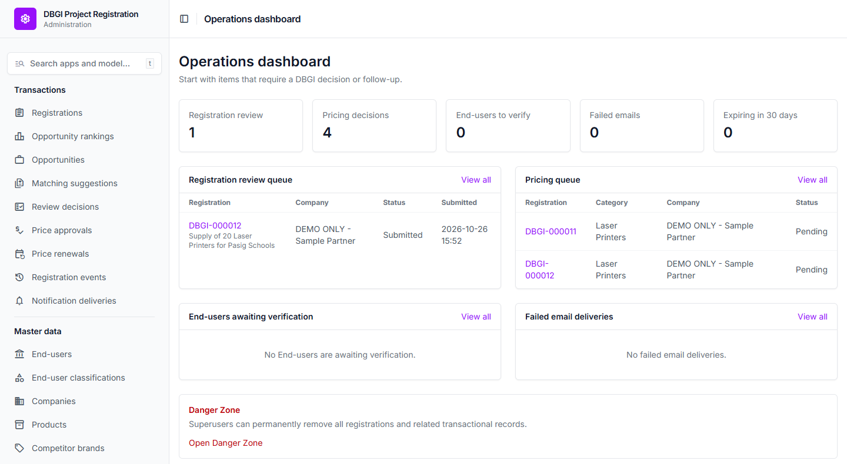
Figure 9. The Operations dashboard.
The Danger Zone at the bottom of the dashboard permanently deletes data. Only superusers can open it.

Step 2: start the review
- Read the System recommendation and Match score. They are suggestions, not decisions.
- Compare the End-user, address, products, and evidence yourself.
- Write a short Review reason and select START REVIEW. This only records that the review has started.
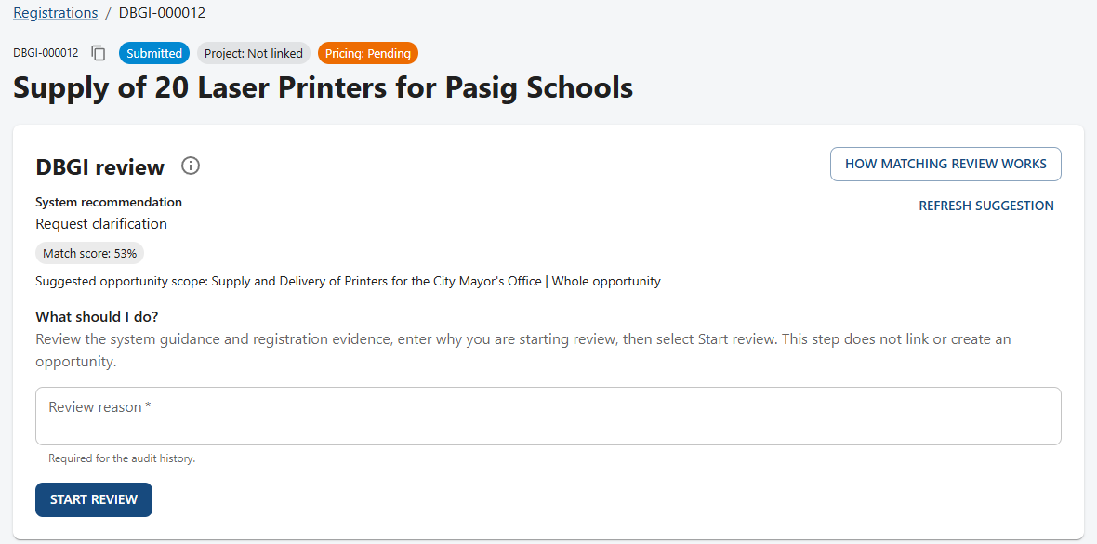
Figure 10. The DBGI review panel before the review starts.
Never confirm a match from the score alone. In the example the score was 53% against a different Pasig project.

Step 3: choose exactly one decision
Decision | Use it when
Link to an existing opportunity | The registration belongs to a procurement that is already in the portal.
Create a new whole opportunity | No existing opportunity fits.
Request changes | Information is missing or wrong. Write exact instructions the company can follow.
Reject registration | The registration should not proceed. Give a clear business reason.
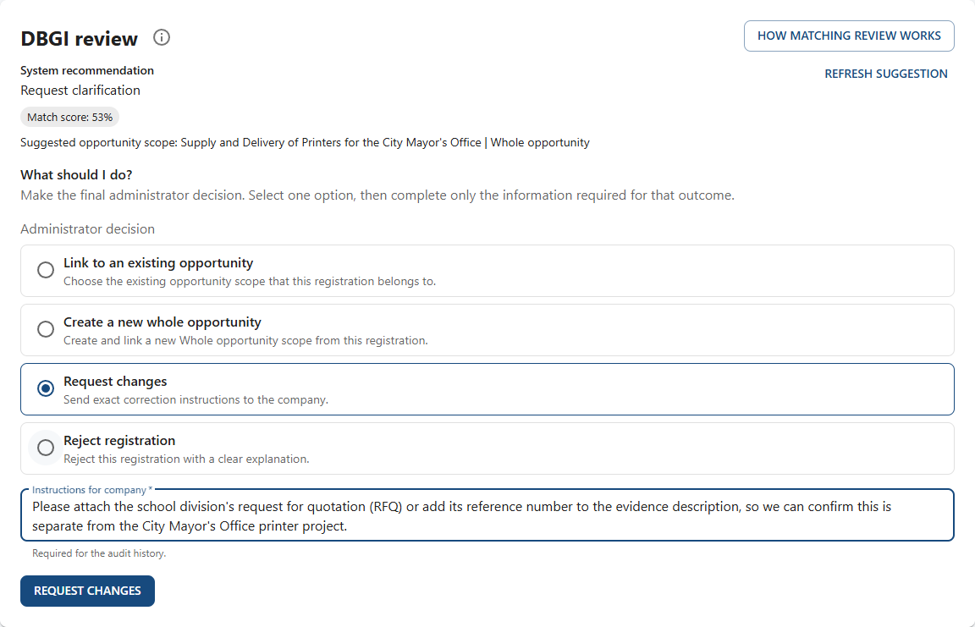
Figure 11. Requesting changes with exact instructions.

Expected result
The registration shows Changes requested. The company receives a notification and can read the instructions in Activity.

5. Correct a registration and resubmit
Who: Company user
Before you start: a registration with status Changes requested.
- Open the Changes requested notification, or open the registration.
- Scroll to Activity. DBGI's exact instructions are under the Request changes entry.
- Select EDIT REGISTRATION.
- Change only the fields DBGI mentioned. In the example, the RFQ reference was added to the evidence description.
- Review the whole record and select SAVE CHANGES.
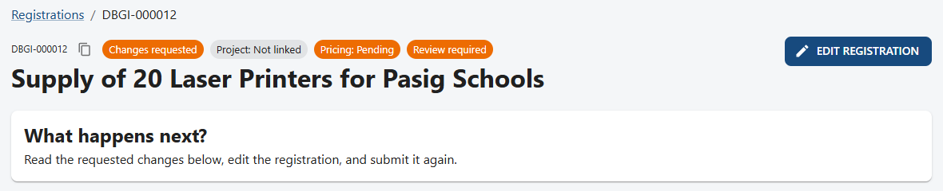
Figure 12. The registration after DBGI requested changes.
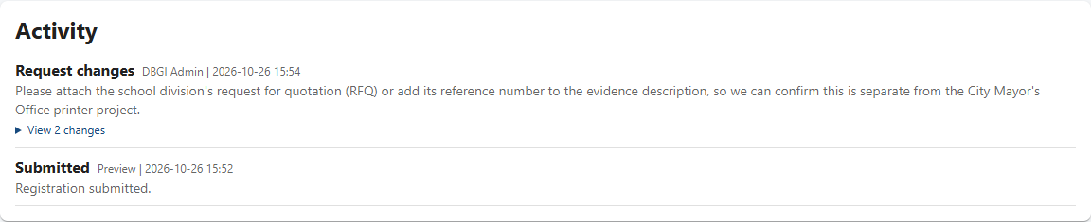
Figure 13. DBGI's instructions in Activity.
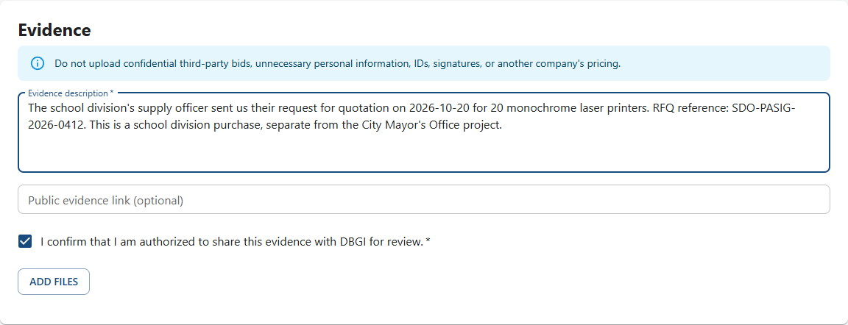
Figure 14. Adding the requested RFQ reference to the evidence.

Expected result
The status becomes Resubmitted and the registration goes back to DBGI. Activity records exactly what changed.
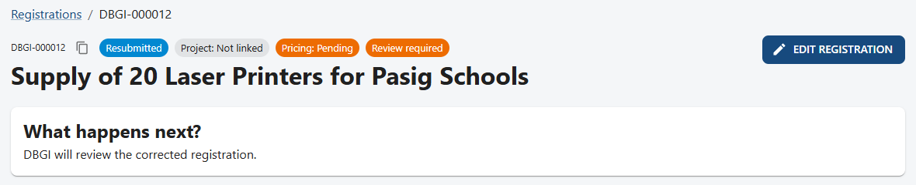
Figure 15. The corrected registration, back with DBGI.
Editing a registration that is already Registered also sends it back for review.

6. Check the correction and confirm the registration
Who: DBGI administrator
Before you start: a Resubmitted registration.
- Open the registration. In Activity, open View changes under Company edit to compare old and new values.
- Write a review reason and select START REVIEW again.
- Choose the final decision. In the example: Create a new whole opportunity, because the RFQ shows a school division purchase separate from the City Mayor's Office project.
- Write the Decision reason and select CREATE AND LINK NEW OPPORTUNITY (or LINK EXISTING OPPORTUNITY).
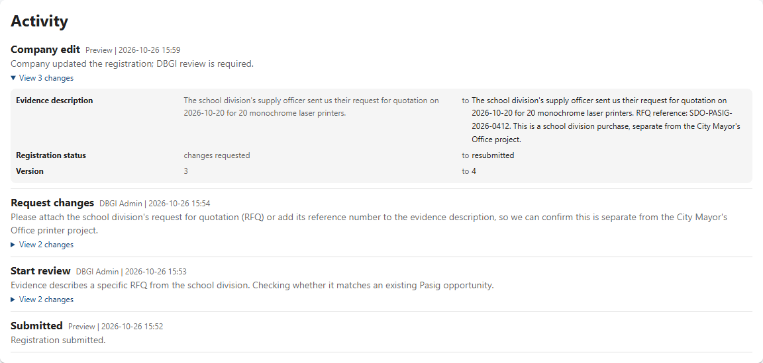
Figure 16. Activity shows the old and new evidence text.
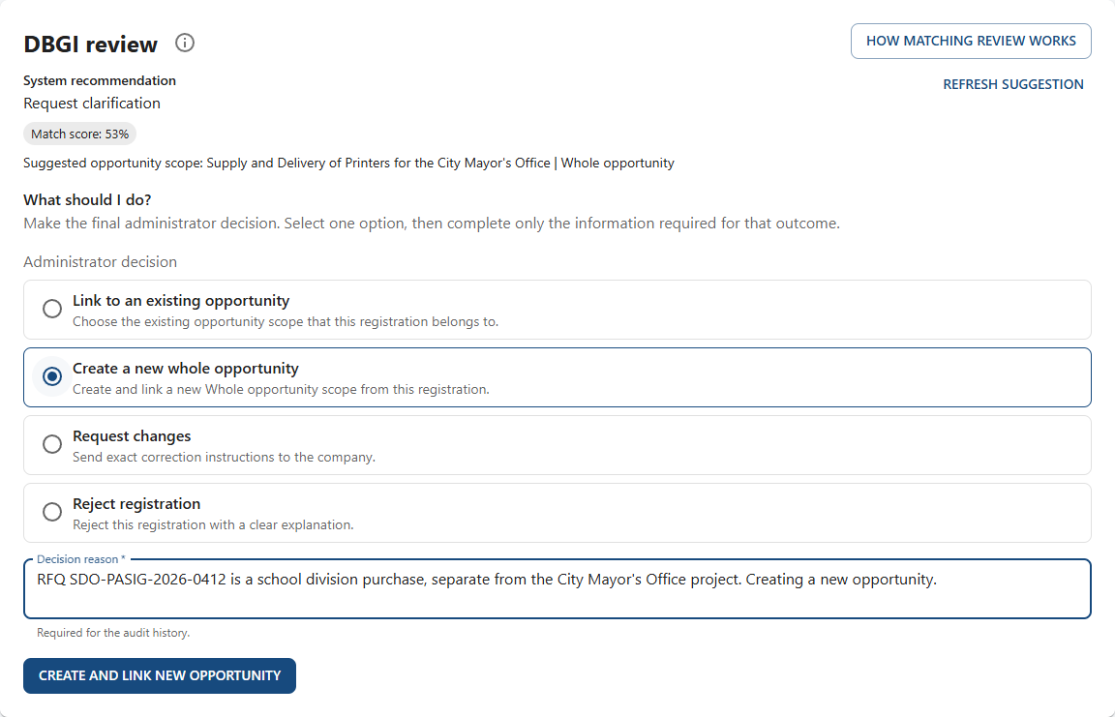
Figure 17. Creating a new whole opportunity.

Expected result
The registration shows Registered and Project: Upcoming. The opportunity now exists, rankings can be calculated, and the company receives a Registration confirmed notification.

7. Approve the price
Who: DBGI administrator
Before you start: a Registered registration with a Pending pricing category.
- Open Administration, then Price approvals, or select the registration in the dashboard's Pricing queue.
- Set Status to Approved, Partially approved, Rejected, or Changes requested.
- Write the Rationale and set Valid until.
- Under Registration item approvals, select Add another Registration item approval, choose the item, and enter the Approved unit price.
- Select Save. Reviewed by and Reviewed at are filled in automatically with your name and the time you saved.
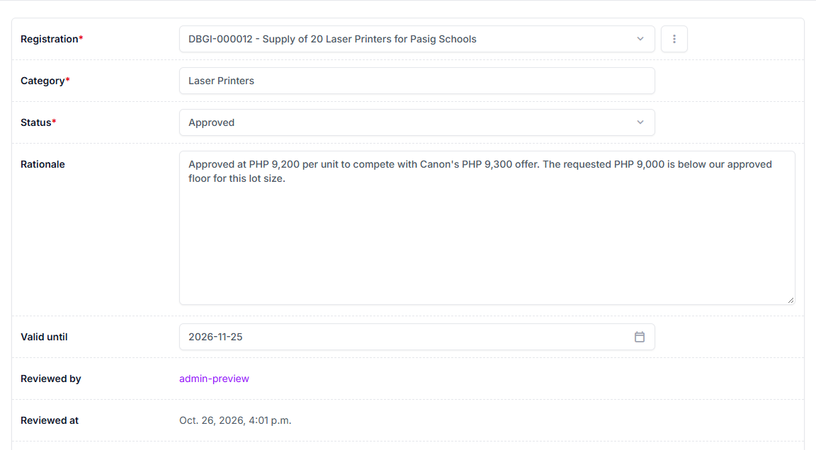
Figure 18. The pricing decision form.
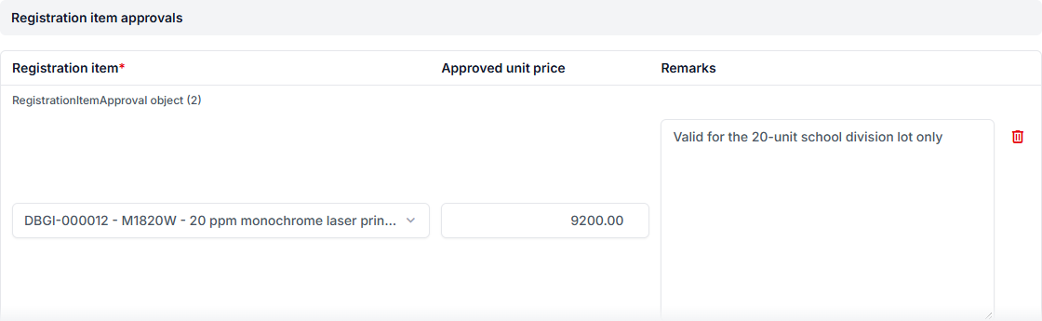
Figure 19. Entering the approved unit price for the item.
The item list offers only this registration's items, each labelled with its reference (for example DBGI-000012 - M1820W), so another registration's item cannot be chosen by mistake.

Expected result
The pricing list shows Approved with its valid-until date, and the company receives a Price request approved notification.

8. See the decision and the approved price
Who: Company user
Before you start: a registration for which DBGI has made a pricing decision.
- Open the Price request approved notification and select VIEW REGISTRATION.
- Check the badges: Registered, Project: Upcoming, Pricing: Approved.
- Under Commercial approvals, read the decision, the valid-until date, the reviewer, and the reason.
- Under Requested products, read the Approved unit price. In the example it is PHP 9,200, not the PHP 9,000 requested.
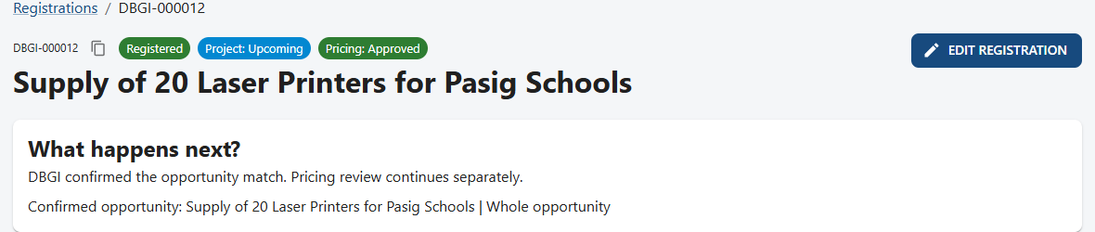
Figure 20. All three badges now have an answer.
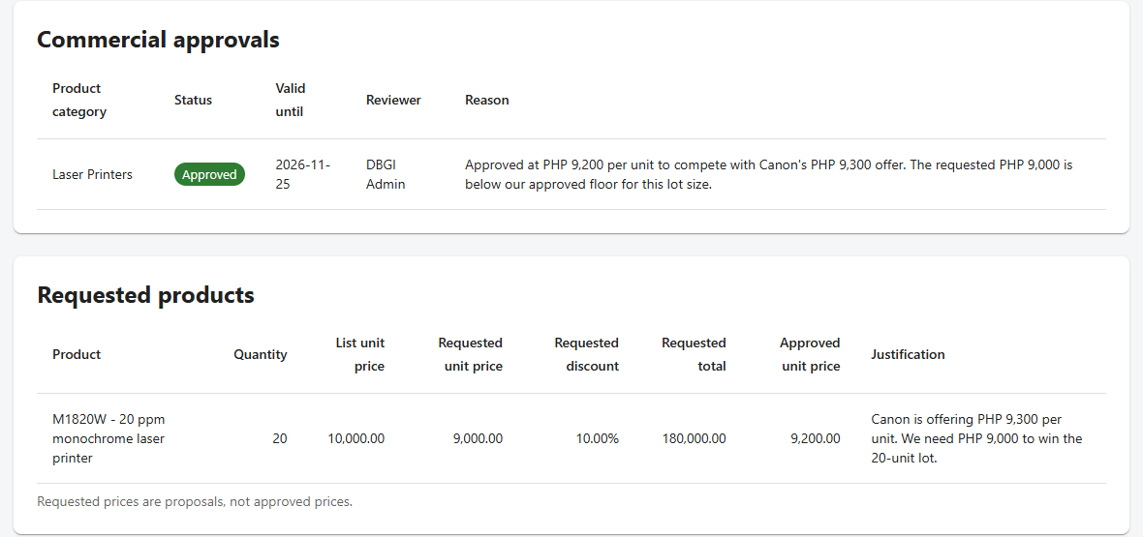
Figure 21. The approved price and its validity.
Quote only the approved unit price, and only until the valid-until date. Never use a requested price for an item that has no approval.
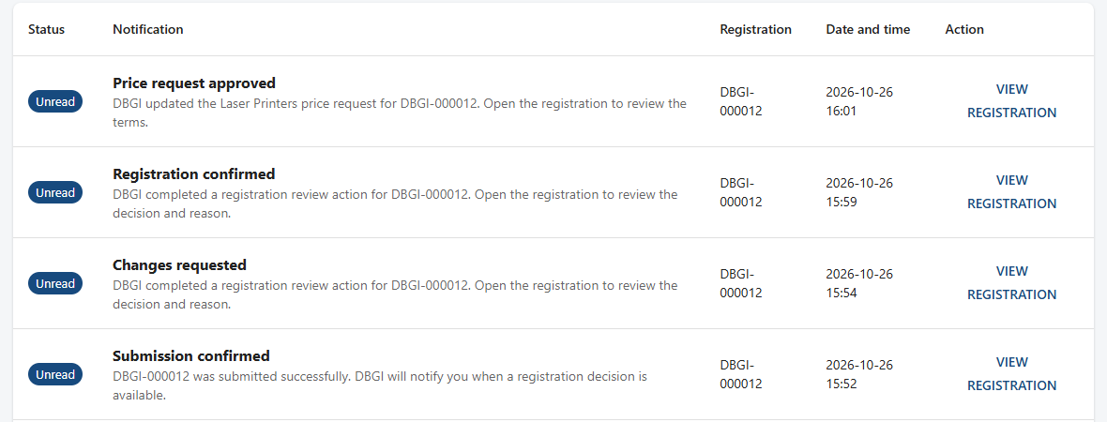
Figure 22. The notifications for DBGI-000012 from submission to price approval.

9. Check your ranking
Who: Company user
Before you start: at least one Registered registration.
- Select RANKINGS in the top menu.
- Each row is a confirmed opportunity your company registered for, with your rank and the date you became eligible.
- You only see your own rank. Other companies and their registrations stay private.
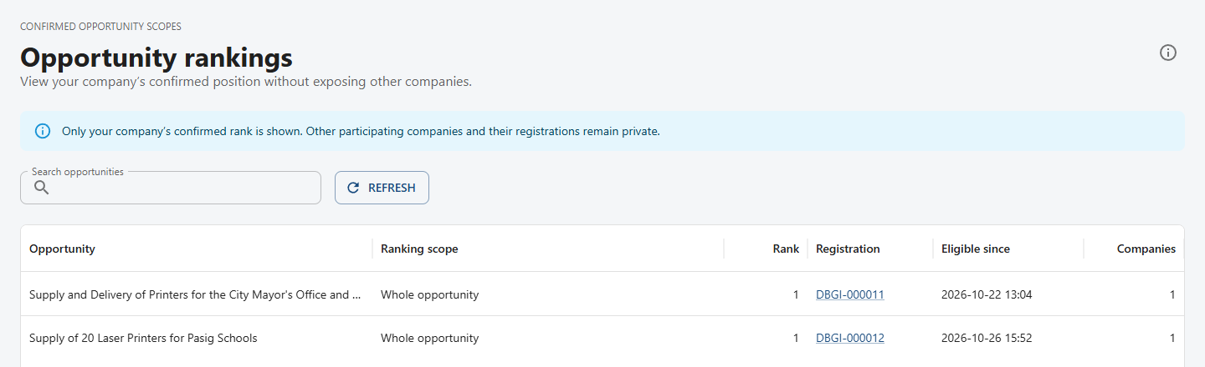
Figure 23. The Opportunity rankings page.

10. Other situations
These are described step by step on the portal's Help page.

The buyer is missing from the End-user list
- Company user: select ADD MISSING END-USER on the registration form and complete the fields. The help buttons on each field show examples.
- DBGI administrator: open Administration, then End-users, and select the pending organization.
- Compare the name and address with an official source, correct them, and add aliases instead of creating a duplicate.
- Verify the End-user, then return to the linked registration and select REFRESH SUGGESTION.

A registration was rejected
- Open the registration and read DBGI's reason in Activity.
- Rejection is a decision about the registration, not a statement that the buyer cancelled the project.
- Do not resubmit the same deal as a new registration. Contact DBGI if you believe the decision is wrong.

An email failed to send (DBGI administrator)
- Open Administration, then Notification deliveries, and select the failed delivery.
- Read the error. Confirm the recipient's email address is correct.
- Fix the address or mail settings, then select the record and run Retry selected failed email deliveries.
- Refresh and confirm the status is Sent. The portal notification was available the whole time.

An approval is about to expire
- The dashboard's Expiring in 30 days card lists approvals that will expire soon.
- Renewals are handled under Administration, Price renewals. Each approved renewal adds 30 days.

11. Golden rules
- A requested price is never an approved price.
- One registration per real opportunity. Edit it; do not duplicate it.
- The portal notification is the official record. Email is only a copy.
- Write reasons and instructions that someone else can act on without asking you.
- Read the three badges separately: registration, project, and pricing.
- Stuck? Open HELP. It shows step-by-step guides for your role.

12. Quick reference
I want to... | Go to
Register a new deal | Registrations, then NEW REGISTRATION
See what DBGI decided | NOTIFICATIONS, then VIEW REGISTRATION
Fix a registration DBGI sent back | Open the registration, read Activity, then EDIT REGISTRATION
See my approved price | Open the registration: Commercial approvals and Requested products
See my rank | RANKINGS
Review a registration (DBGI) | Administration dashboard, Registration review queue
Decide a price (DBGI) | Administration, Price approvals
Verify a new End-user (DBGI) | Administration, End-users
Retry a failed email (DBGI) | Administration, Notification deliveries
Get step-by-step help | HELP in the top menu
Screens captured from the portal's test environment on 2026-10-26.

